JavaScript Notes

💡 What is JavaScript?
JavaScript is a scripting language that runs in the browser and allows you to create interactive elements on websites such as dynamic content, sliders, pop-ups, animations, form validations, etc.

📜 JavaScript History
- Created in 1995 by Brendan Eich at Netscape in just 10 days.
- Initially named Mocha, then LiveScript, and finally JavaScript (for marketing, not related to Java).
- Standardized as ECMAScript in 1997 by ECMA International.
- Major version:
  - ES5 (2009) – Added JSON, strict mode.
  - ES6 (2015) – Introduced let, const, arrow functions, classes.
  - Later versions added async/await, optional chaining, etc.
- Now used for web, mobile, games, and server apps (via Node.js).

💡 What is ECMA in JavaScript?
ECMA stands for European Computer Manufacturers Association.ECMA is the organization that standardizes JavaScript under the name ECMAScript.

🔹 How JavaScript Works in the Browser
When you open a webpage, your browser (like Chrome, Firefox, Edge) loads HTML, CSS, and JS.
Here’s what happens with JavaScript:

1. Loading & Parsing
- The browser reads the HTML file.
- If it finds a <script> tag, it fetches the JavaScript code.

2. Execution by JavaScript Engine
Every browser has a JavaScript Engine:
- Chrome → V8
- Firefox → SpiderMonkey
- Safari → JavaScriptCore
- Edge → Chakra (older)
The engine converts JS code into machine code so the computer can run it.

🔹 Inside the JavaScript Engine
The process happens in steps:
- Parsing → The JS code is read and converted into a structure (AST - Abstract Syntax Tree).
- Compilation → Modern engines use JIT (Just-In-Time) Compilation, which makes JS faster by compiling parts of code while running.
- Execution → The compiled code runs on the CPU.
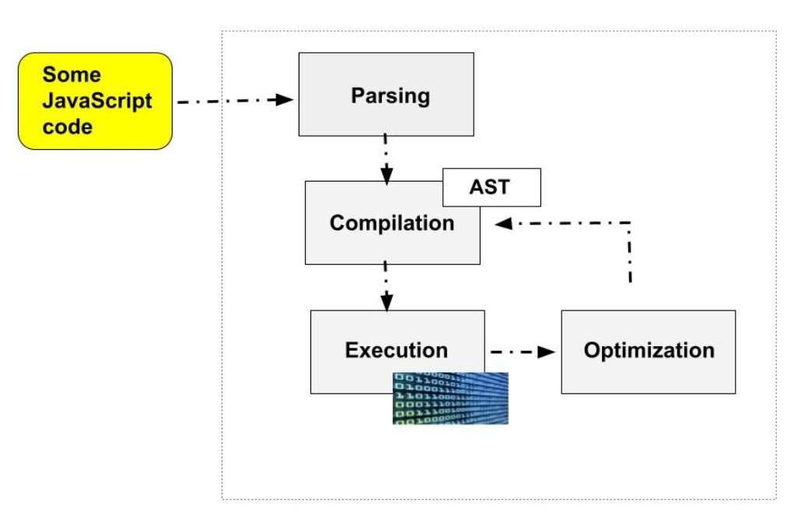

🔹 JavaScript Runtime Environment
JavaScript itself is single-threaded (runs one thing at a time).
But browsers give JS extra features through the runtime environment, which includes:
- Call Stack → Keeps track of what function is being executed.
- Heap → Where memory (variables, objects) is stored.
- Web APIs → Extra features provided by the browser (like setTimeout, DOM manipulation, fetch requests).
- Callback Queue / Task Queue → Holds tasks that should run later.
- Event Loop → Constantly checks the call stack and the queue to run tasks at the right time.

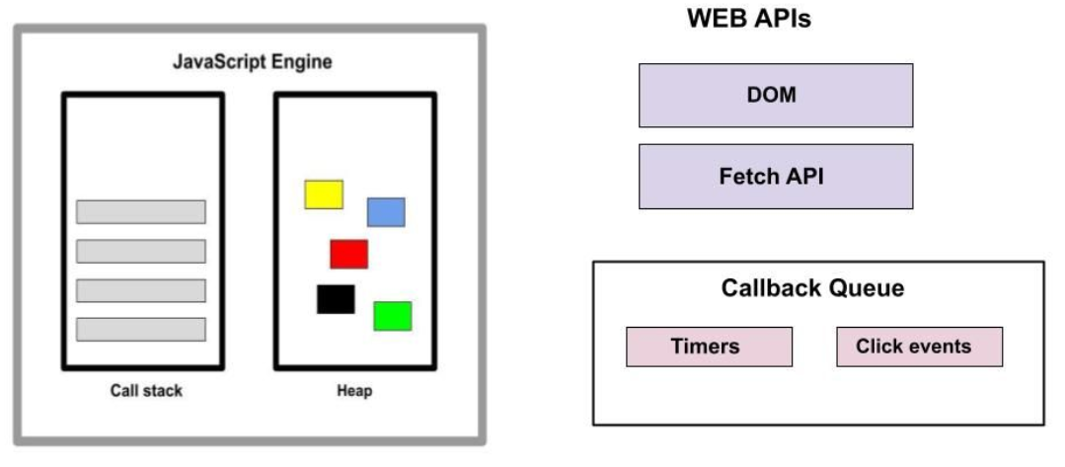

Three Ways to Add JavaScript in HTML:

1. Inline JavaScript
JavaScript is written directly inside an HTML element using the onclick, onmouseover, etc.
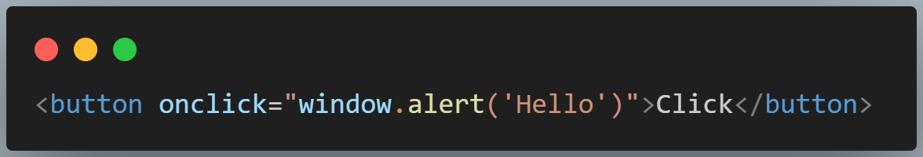

2. Internal JavaScript
JavaScript is written inside a <script> tag in the HTML <head> or <body>.
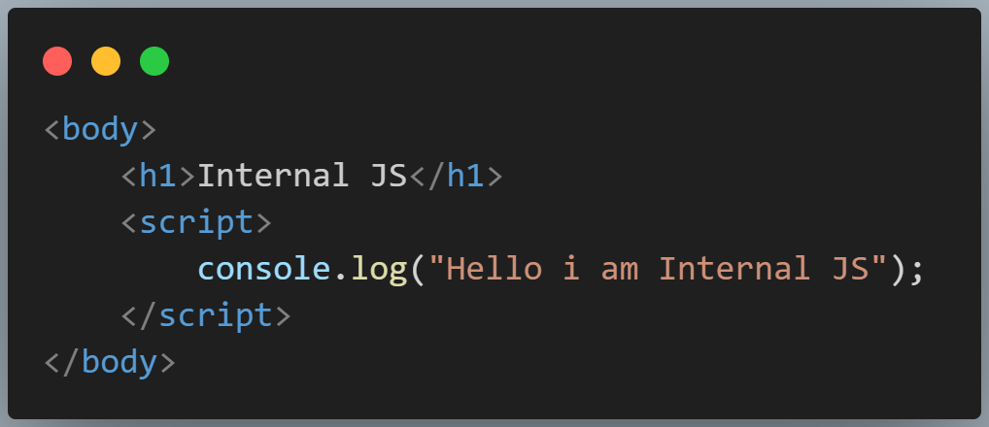

3. External JavaScript
JavaScript is written in a separate .js file and linked with the HTML using the src attribute.
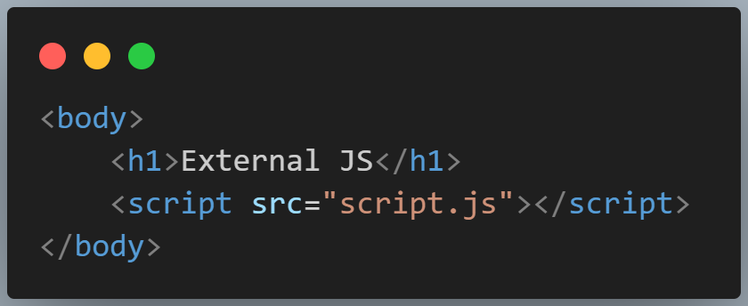
Variable:- a variable is simply a named container that stores data.It allows you to save a value (like a number, text, or object) and use it later in your program.

🔹 Declaring a Variable in JavaScript
JavaScript provides three keywords to declare variables:
- var → old way (function-scoped, can be re-declared).
- let → modern way (block-scoped, can be updated but not re-declared in the same scope).
- const → modern way (block-scoped, cannot be updated or re-declared, must be assigned when declared).
Variable naming rules in points:
- A variable must start with a letter (a–z, A–Z), an underscore (_), or a dollar sign ($).
- A variable cannot start with a number.
- A variable cannot use reserved keywords (like if, for, while, class, etc.).
- Variable names are case-sensitive → age, Age, and AGE are all different.
- Variable names cannot contain spaces.
- Variable names cannot contain special characters (like @, #, -, !, etc.) except _ and $.
- Variable names can contain numbers, but not at the beginning.
  - Example: value1 ✅ but 1value ❌
- Always use meaningful and descriptive names (best practice, not a strict rule).
- Use camelCase naming convention while creating a variable.

A data type in JavaScript means the kind of value a variable can hold.It tells the computer what type of data is stored (like a number, text, true/false, list, etc.) and how it should be used.

🔹 Primitive Data Types
- Number → integers and decimals (10, 3.14)
- String → text values ("Hello", 'World', `Hi`)
- Boolean → true or false
- Undefined → a variable declared but not given a value
- Null → represents "nothing" or empty value
- Symbol → unique and immutable value (used as object keys)
- BigInt → large integers (12345678901234567890n)

🔹 Non-Primitive (Reference) Data Types
- Object → key-value pairs ({name: "John", age: 25})
- Array → ordered list ([1, 2, 3, 4])
In JavaScript, type casting (also called type conversion) is the process of converting a value from one type to another.
There are two main types:

1. Implicit Type Casting (Type Coercion)
JavaScript automatically converts values when needed.

2. Explicit Type Casting (Manual Conversion)
You can explicitly convert types using built-in functions.

What is prompt()?
The prompt() function is a built-in JavaScript method that displays a modal dialog box with:
- a message (label) for the user,
- a text input field,
- and OK / Cancel buttons.
It is mainly used to collect input from the user in a very simple way.
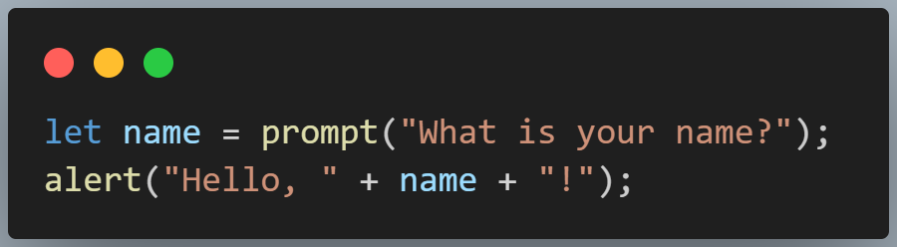

🔹 Return Values
- If the user enters something and clicks OK → returns a string with that value.
- If the user clicks Cancel → returns null.
- If the user clicks OK without typing anything → returns an empty string "".

Operator is a special symbol used to perform operations on values (operands).Operators allow you to manipulate data, perform calculations, and make decisions in code.

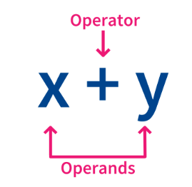

🔹 Types of Operators in JavaScript:

1. Arithmetic Operators (used for mathematical calculations)
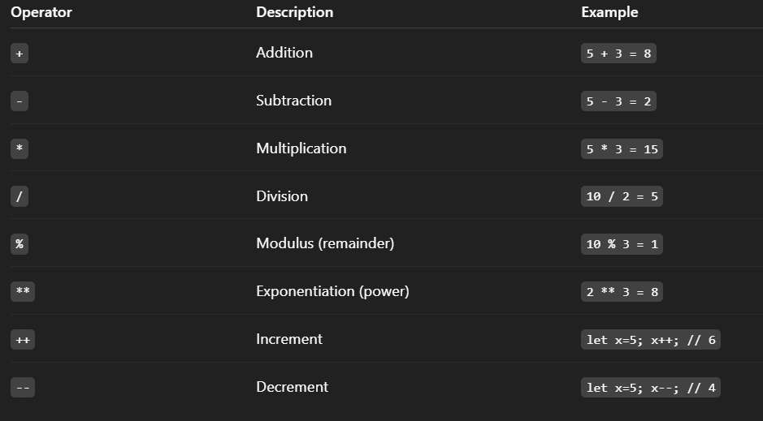

2. Assignment Operators (assign values)

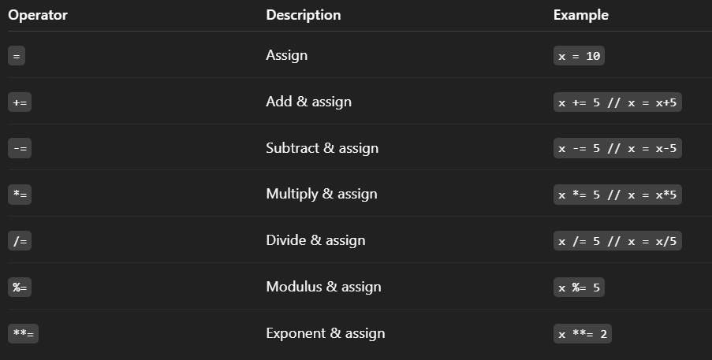

3. Comparison Operators (used to compare values, returns true or false)
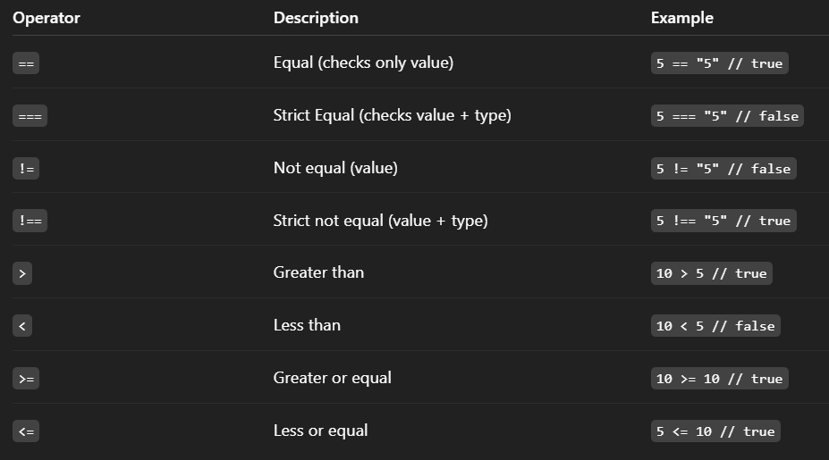

4. Logical Operators (combine conditions)

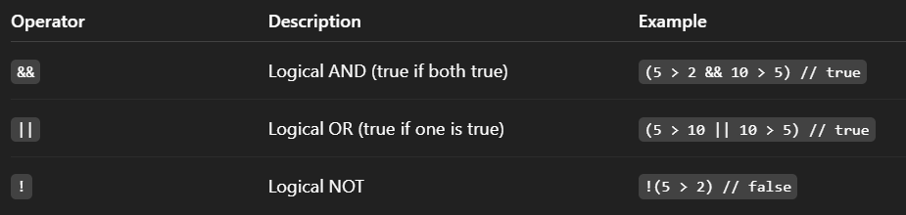

5. Bitwise Operators (work on binary numbers)
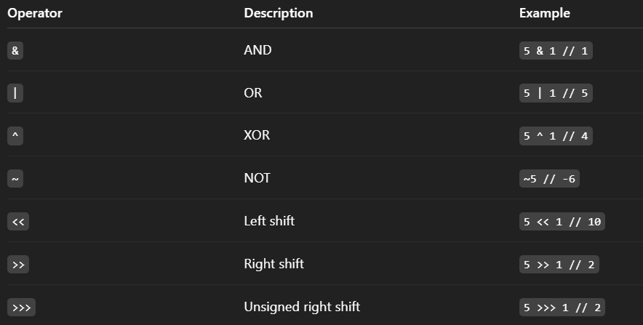

6. Ternary Operator (Conditional Operator)

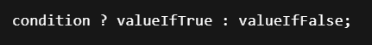
7. Type Operators
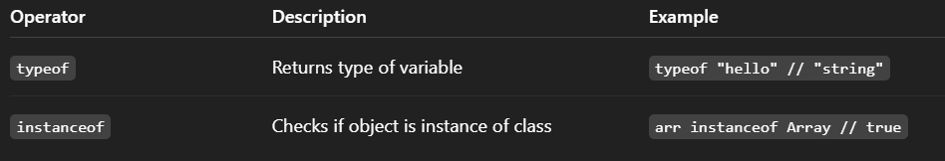
8. Nullish Coalescing Operator (??)
Returns right-hand value only if left-hand value is null or undefined.

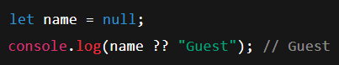

In JavaScript, a conditional statement is used to make decisions in the code. It allows the program to execute certain blocks of code only if a specific condition is true.

1. if statement
The if statement is used to test a condition. If the condition is true, the block of code inside it executes.
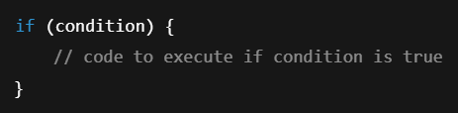

2. if...else statement
The if...else statement executes one block of code if the condition is true, otherwise executes another block.
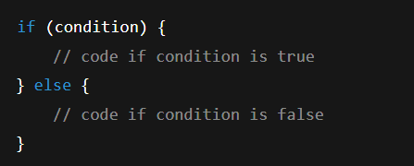

3. if...else if...else statement
This statement allows you to test multiple conditions.
- The first condition is checked.
- If false, the next else if is checked.
- If no conditions are true, the else block executes.
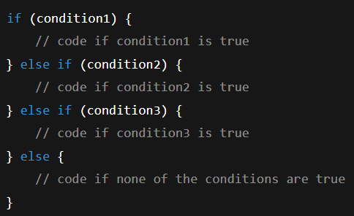

4. switch statement
The switch statement is used when you want to compare the same value/expression against multiple possible matches.
It is an alternative to using many else if statements.
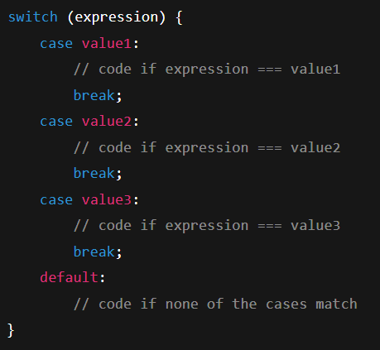
In JavaScript, a loop statement is used to repeatedly execute a block of code as long as a certain condition is true.
Loops help in avoiding repetitive code.

Types of Loop Statements in JavaScript

1. for loop
Used when you know how many times you want to run the loop.
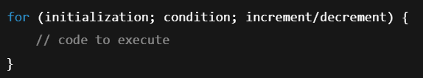

2. while loop
Used when you don’t know the exact number of iterations and want to run until a condition becomes false.
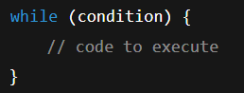

3. do...while loop
Similar to while, but executes the code at least once before checking the condition.
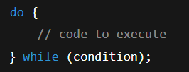

4. for...in loop
Used to loop through the properties of an object.
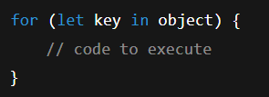

5. for...of loop (ES6)
Used to loop through iterable objects like arrays, strings, etc.
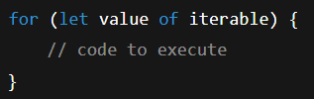
In JavaScript, jump statements are used to change the normal flow of program execution. They allow us to jump out of loops, skip iterations, or return from functions.

Types of Jump Statements in JavaScript

1. break statement
Used to exit from a loop or switch immediately.
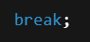

2. continue statement
Used to skip the current iteration of the loop and move to the next iteration.
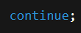
A string is a sequence of characters enclosed in single quotes ('), double quotes ("), or backticks (`).
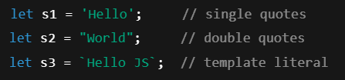
Length → length gives number of characters.
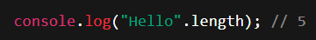

JavaScript String Methods List

1. Character Access
- charAt(index) → Returns character at given index.
- charCodeAt(index) → Returns UTF-16 code of character.
- codePointAt(index) → Returns Unicode code point.
- at(index) → Returns character at index (supports negative index).

2. String Concatenation
- concat(str1, str2, …) → Join two or more strings.

3. Substring Extraction
- slice(start, end) → Extracts part of string.
- substring(start, end) → Extracts part (no negative index).
- substr(start, length) → Extracts substring (deprecated, but still works).

4. Search & Match
- indexOf(searchValue, fromIndex) → Returns index of first match.
- lastIndexOf(searchValue) → Returns index of last match.
- search(regexp) → Returns index of match using regex.
- match(regexp) → Returns match results of regex.
- matchAll(regexp) → Returns iterator of all regex matches.
- includes(searchString) → Checks if string contains substring.
- startsWith(searchString, position) → Checks start of string.
- endsWith(searchString, length) → Checks end of string.

5. Replace
- replace(searchValue, newValue) → Replaces first match.
- replaceAll(searchValue, newValue) → Replaces all matches.

6. String Modification
- toUpperCase() → Converts to uppercase.
- toLowerCase() → Converts to lowercase.
- trim() → Removes spaces from both ends.
- trimStart() / trimLeft() → Removes leading spaces.
- trimEnd() / trimRight() → Removes trailing spaces.
- padStart(targetLength, padString) → Pads from start.
- padEnd(targetLength, padString) → Pads from end.
- repeat(count) → Returns repeated string.
- normalize(form) → Normalizes Unicode text.

7. Splitting & Joining
- split(separator, limit) → Splits string into array.

8. Conversion
- toString() → Converts String object to primitive string.
- valueOf() → Returns primitive string value.

9. Iteration
- [Symbol.iterator] → Allows iteration over characters (for…of loop).

An array is a special type of object used to store multiple values in a single variable.
It is an ordered collection of elements, where each element has an index (position) that starts from 0.

✅ Key Points about Arrays in JS:
- Stores multiple values (numbers, strings, objects, or even functions).
- Index-based → The first element is at index 0.
- Dynamic size → Arrays can grow or shrink as needed.
- Can store mixed data types in one array.
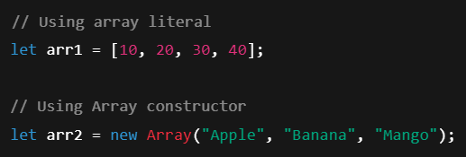
Methods of array :-

🔹 Adding & Removing
- push() → add element at the end
- pop() → remove last element
- unshift() → add element at the beginning

🔹 Searching
- indexOf() → find index of an element
- includes() → check if an element exists
- find() → get first element that matches a condition
- findIndex() → get the index of first element that matches

🔹 Transforming
- map() → create new array by transforming each element
- filter() → create new array with elements that pass a test
- reduce() → reduce array to a single value (like sum)

🔹 Reordering
- sort() → sort array
- reverse() → reverse array
- slice() → copy part of array (doesn’t change original)
- splice() → add/remove elements (changes original)

🔹 Joining
- concat() → join arrays
- join() → turn array into string
- toString() → similar to join but with commas

When we talk about higher-order methods for arrays in JS, we mean methods that either:
- Take another function as an argument (called a callback), or
- Return a function.
Array higher-order methods make it much easier to work with lists of data without writing long loops.
Some of the most common ones are:

forEach()
👉 Runs a function on each element (does not return a new array).
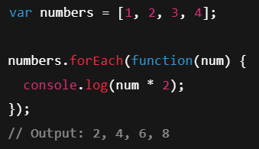

map()
Definition: Creates a new array by applying a function to each element of the original array.
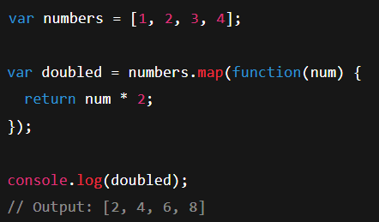

filter()
Definition: Returns a new array with elements that satisfy a given condition.
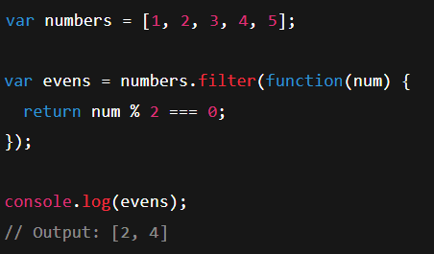

reduce()
Definition: Reduces the array to a single value by applying a function to each element (e.g., sum, product).
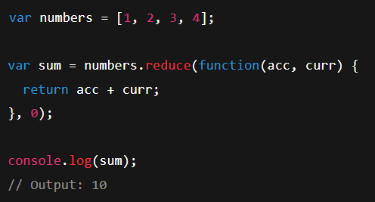

find()
Definition: Returns the first element in the array that matches a condition.
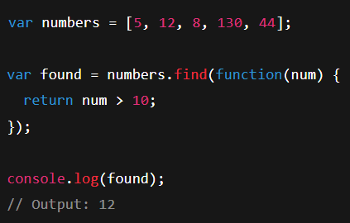

some()
Definition: Returns true if at least one element in the array satisfies the condition.
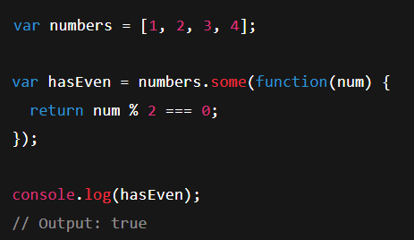

every()
Definition: Returns true if all elements in the array satisfy the condition.
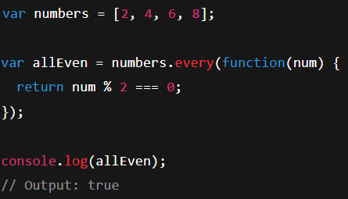
An object is basically a collection of related data and functionality — kind of like a box that holds information (properties) and actions (methods).
Think of it this way:
- A property is like a variable stored inside an object.
- A method is like a function stored inside an object.
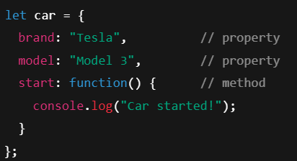

Methods of objects :-

1. Object.keys(obj)
Returns an array of the object’s property names (keys).
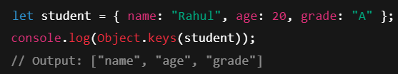

2. Object.values(obj)
Returns an array of the object’s property values.
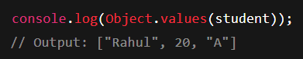

3. Object.entries(obj)
Returns an array of [key, value] pairs.
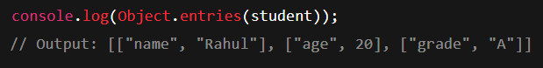

4. Object.assign(target, source)
Copies properties from one object to another.
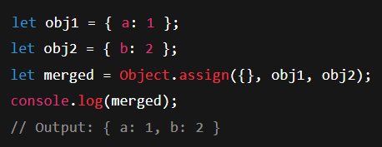

5. Object.freeze(obj)
Prevents changes (no add/update/delete) to the object.
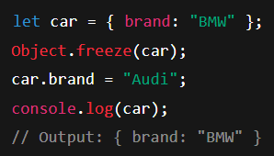

6. Object.seal(obj)
Prevents adding or deleting properties, but allows modifying existing values.
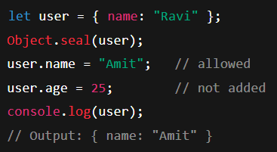

7. Object.create(proto)
Creates a new object with the specified prototype.
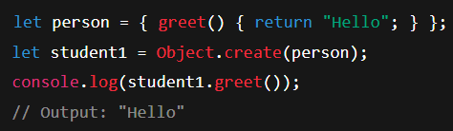

8. Object.hasOwn(obj, key) (ES2022)
Checks if an object has a property (like hasOwnProperty).
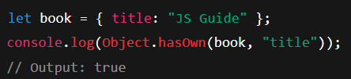

9. obj.hasOwnProperty(key)
Checks if the property belongs to the object itself (not inherited).
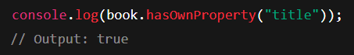

10. Object.getOwnPropertyNames(obj)
Returns an array of all property names (including non-enumerable).
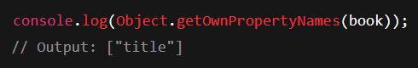

What is a Function?
A function is a block of code designed to perform a specific task.
It can be called (invoked) whenever needed.Advantage : Code Reusability.
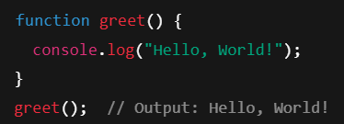

Function Expression
Store a function inside a variable.
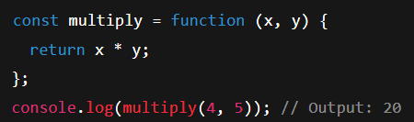

Arrow Function (ES6)
A shorter way to write functions.
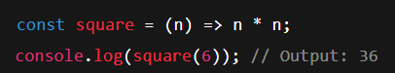

Default Parameters
Set default values for parameters.
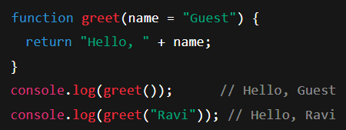

Rest Parameters (...)
Allows passing multiple arguments as an array.
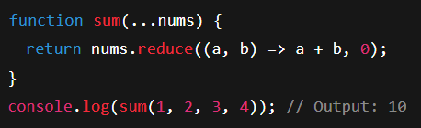

Anonymous Functions
Functions without a name (often used in callbacks).
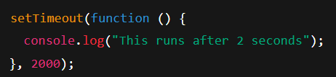

Callback Functions
Passing a function as an argument to another function.
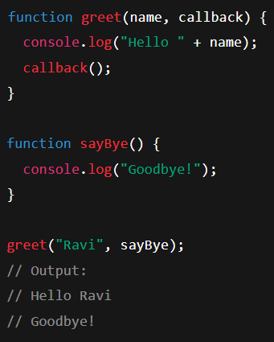

Higher-Order Functions
A function that takes another function as an argument or returns a function.
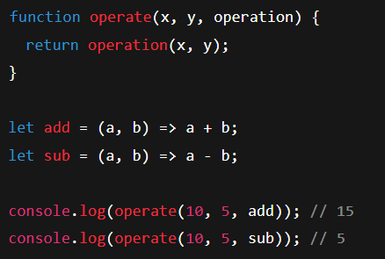

Immediately Invoked Function Expression (IIFE)
Runs immediately after being defined.
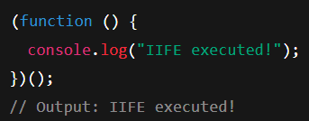

Nested Functions
Functions inside other functions.
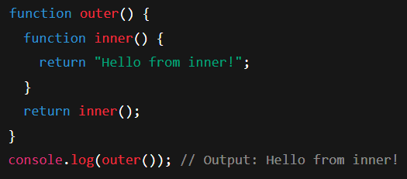

Closures
A function that remembers variables from its parent scope even after the parent has finished executing.
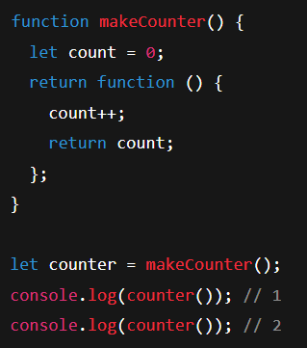

Function Constructor
You can create functions using the Function constructor.
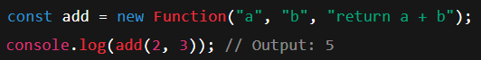

Async Functions (ES8)
Functions that work with promises using async/await.
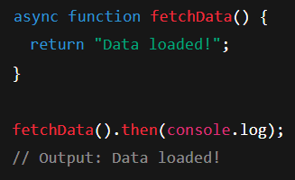

Generator Functions (function*)
Functions that can pause execution using yield.
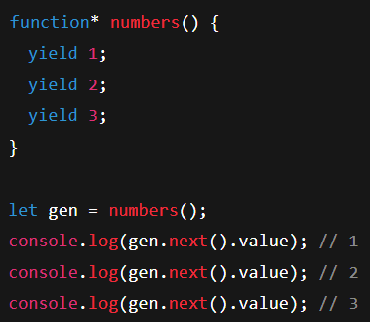

Pure vs Impure Functions
- Pure Function → The same input always gives the same output, no side effects.
- Impure Function → Depends on external factors.
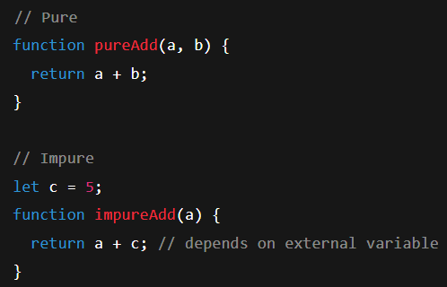

Recursive Functions
A function that calls itself.
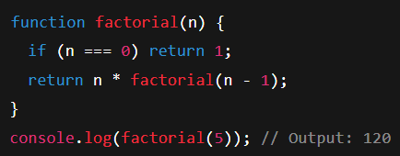
Paradigm : A programming paradigm is a fundamental programming style or approach that provides a framework for writing code and structuring programs to solve problems.

Object-Oriented Programming (OOP) is a way to organize code using objects that combine data (properties) and behavior (methods).

Core Principles of OOP
- Encapsulation → Wrapping data + methods in a single unit (class/object).
- Abstraction → Hiding implementation details, showing only what’s needed.
- Inheritance → Child class inherits features from parent.
- Polymorphism → Same method behaves differently depending on the object.

Object Literals
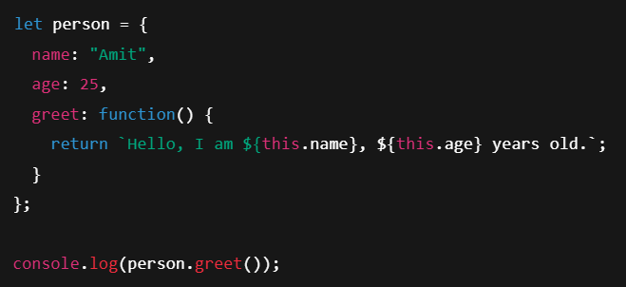

Constructor Function (Before ES6 Classes)
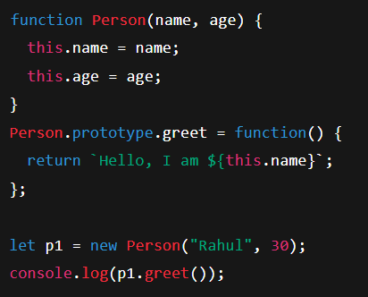
A class serves as a blueprint or template for creating objects. It defines the structure and behavior (properties and methods) that objects of that class will possess.

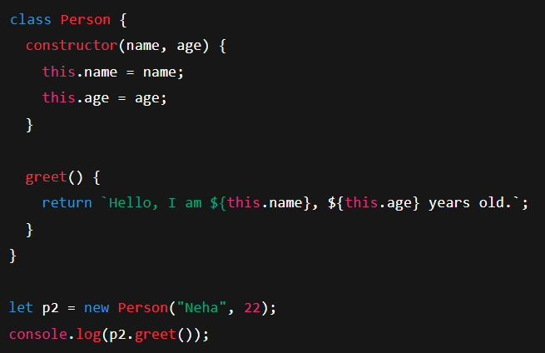

A constructor in JavaScript is a special method used to create and initialize an object created within a class. It's automatically called when a new instance of the class is created using the new keyword.

Key Characteristics
- A constructor's name is always constructor.
- A class can only have one constructor.
- It's used to set up initial properties for the new object.
- If you don't define a constructor, JavaScript provides a default empty one.
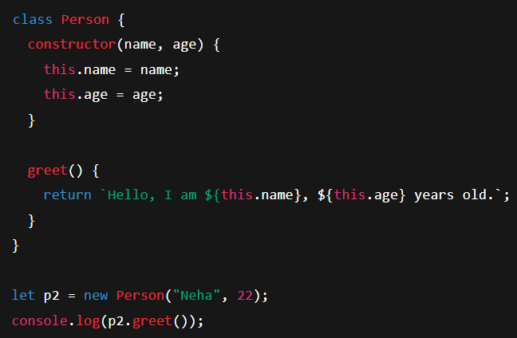

Encapsulation
Keeping data safe & controlled inside the class.
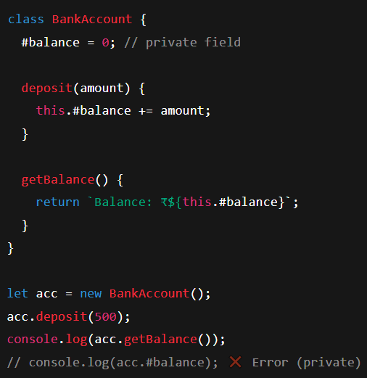

Abstraction
👉 Hiding complex implementation, exposing only necessary methods.
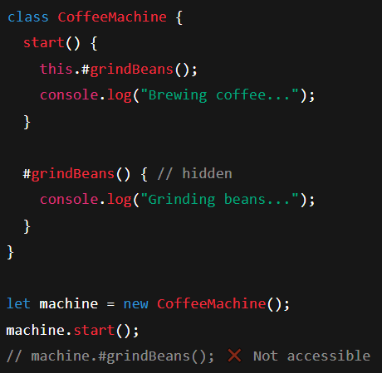

Static Methods
👉 Belong to class, not to objects.
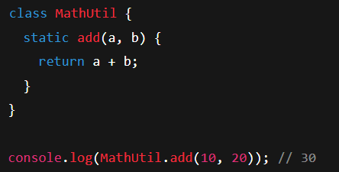

Inheritance in JavaScript is a way for one object (or class) to access the properties and methods of another object (or class).

It promotes code reusability, readability, and helps in building object-oriented designs.

1. Single Inheritance
👉 When a class inherits from one parent class only.
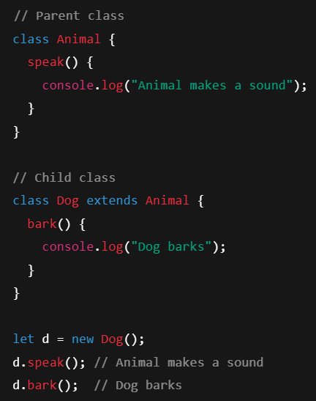

2. Multi-level Inheritance
👉 When a class inherits from a class, and then another class inherits from that child (a chain).
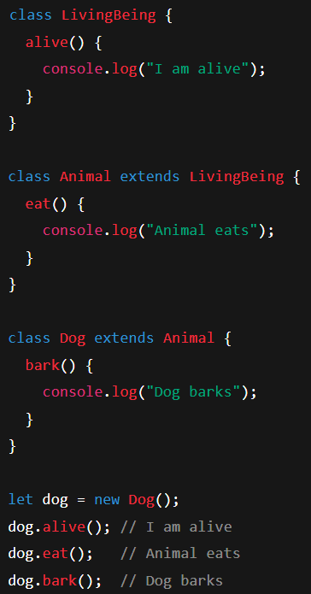

3. Hierarchical Inheritance
👉 Multiple child classes inherit from the same parent class.
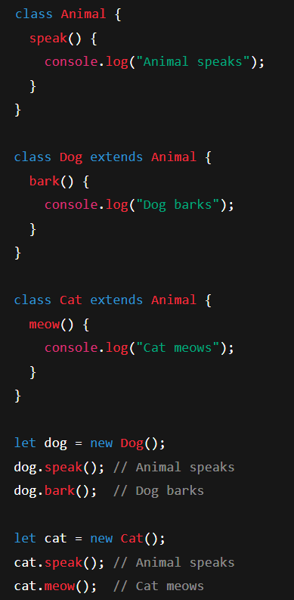

4. Multiple Inheritance
JavaScript doesn’t support multiple inheritance directly (a class can’t extend two classes).
However, you can mimic it using mixins.
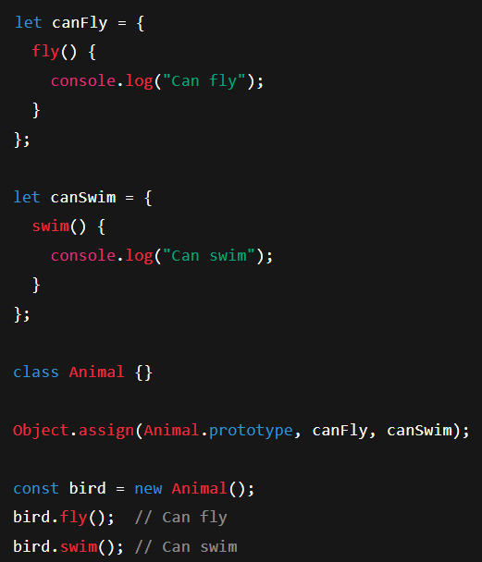

5. Prototypal Inheritance (Core in JavaScript)
👉 Objects can inherit directly from other objects using prototype.
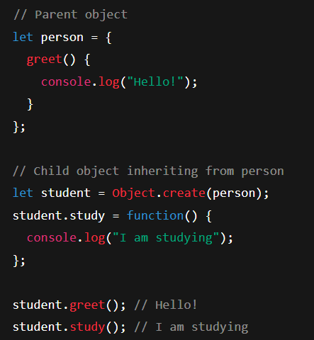

Polymorphism means "many forms".
In OOP (Object-Oriented Programming), polymorphism allows different classes to define the same method name but with different behaviors.
It helps in code reusability, flexibility, and readability.

✅ Types of Polymorphism in JavaScript
JavaScript mainly supports two types:
- Compile-time Polymorphism (Method Overloading)
  - Same method name with different parameters.
  - ❌ Not natively supported in JavaScript (unlike Java, C++).
  - ✅ We can simulate it using default parameters or argument handling.
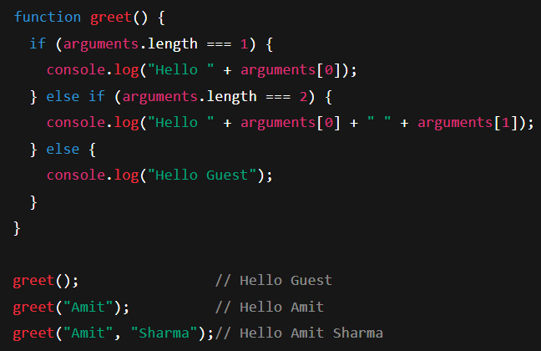

- Run-time Polymorphism (Method Overriding)
  - A child class overrides a parent class method with the same name.
  - ✅ Fully supported in JavaScript.
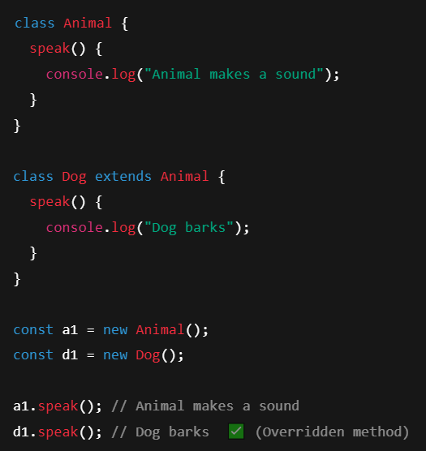

Destructuring in JavaScript is a way to unpack values from arrays or properties from objects into separate variables in a simple, clean syntax.
It makes code shorter and more readable.
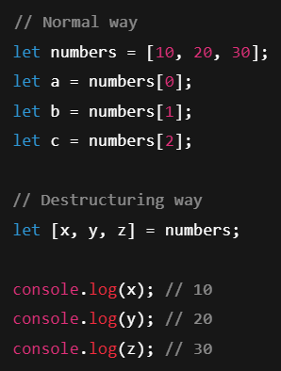

In simple terms, the DOM (Document Object Model) is a live, interactive map of a webpage that JavaScript can read and change. 🗺️
When your browser loads an HTML file, it doesn't just display it. It creates a structured, tree-like model of the page in memory. This model is the DOM. Each part of the HTML document—like the <body>, <h1> headings, <p> paragraphs, or <div> containers—becomes an object, or a "node", in this tree.

In JavaScript (DOM), there are multiple ways to select elements. Here’s a full list with examples:

1. By ID
Selects a single element with a specific ID.

2. By Class Name
Returns a collection (HTMLCollection).
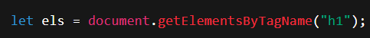

3. By Tag Name
Selects all elements with a specific tag.

4. By Name Attribute
Commonly used in forms.

5. By CSS Selector (first match only)
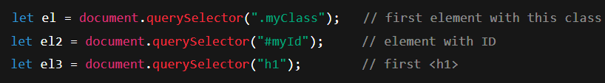

6. By CSS Selector (all matches)
Returns a NodeList of all matched elements.

What is Exception Handling?
- Exception Handling in JavaScript is the process of handling runtime errors (unexpected situations) in a controlled way, so the program doesn’t crash.
- Errors can occur due to invalid user input, missing files, wrong API calls, etc.
JavaScript provides:
- try → Code that might throw an error.
- catch → Handles the error if it occurs.
- finally → Runs code regardless of whether an error occurred.
- throw → Used to create custom errors.
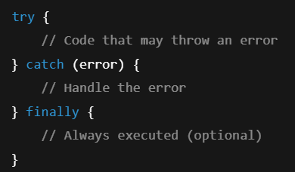

Example 1: Basic try-catch

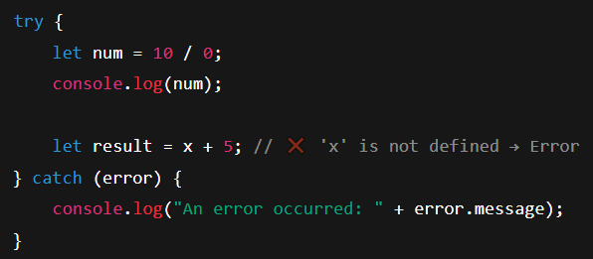
Example 2: try-catch-finally

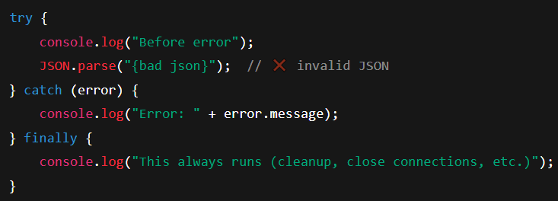

Example 3: throw (Custom Errors)

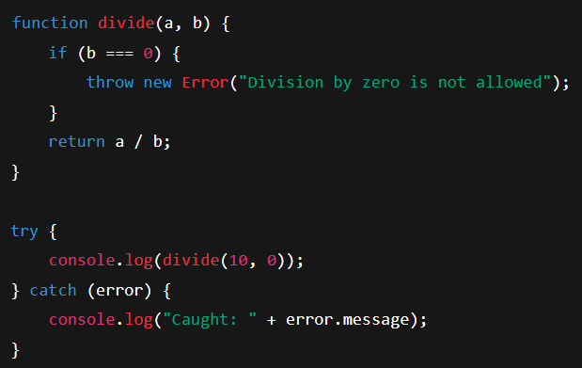

Built-in Error Types in JavaScript

1. Error
- The base error object from which all other errors inherit.
- You usually see it when you throw new Error() yourself.
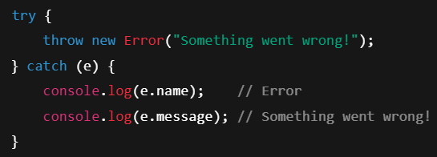

2. ReferenceError
- Happens when you use a variable that doesn’t exist.
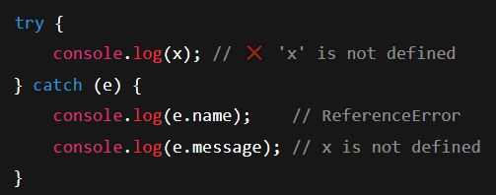

3. TypeError
- Happens when you use a value in an invalid way (wrong data type).
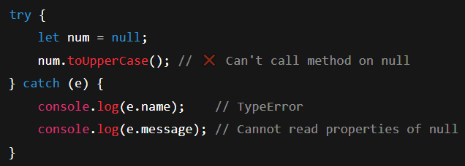

4. SyntaxError
- Happens when your code has invalid syntax.
- Normally caught at parse time, not runtime.
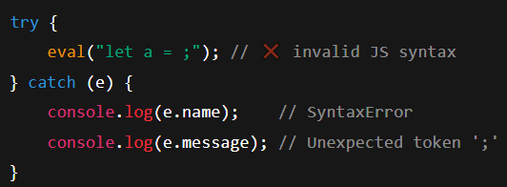

5. RangeError
- Happens when a number is out of range or not valid for the operation.
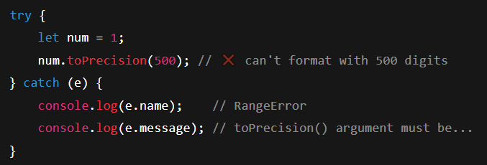

6. URIError
- Happens when you pass invalid parameters to URI handling functions like decodeURI() or encodeURI().
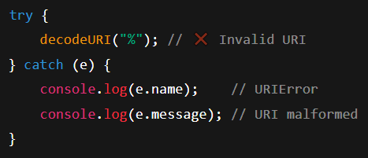

7. EvalError (Rare)
- Related to the eval() function (used to run code as a string).
- It’s not thrown by modern JavaScript engines often, but still exists.
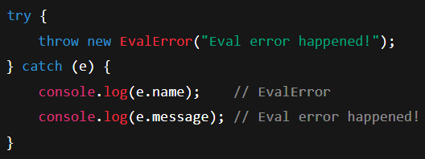

Summary Of all Errors:-

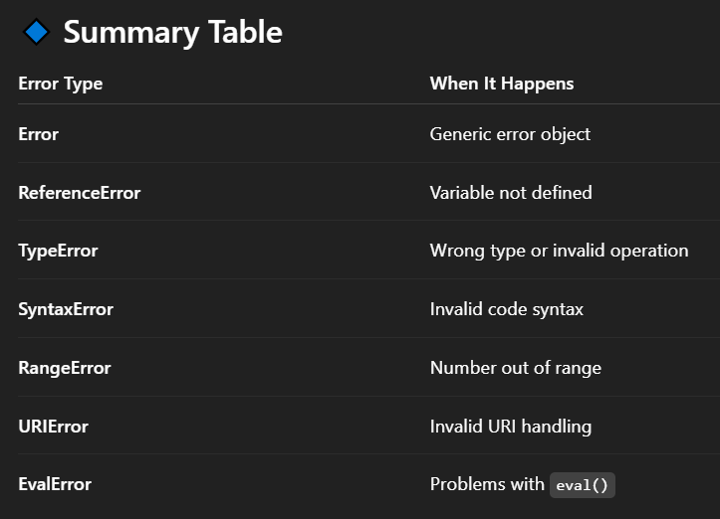

What is a Callback in JavaScript?
A callback is a function passed as an argument to another function, which is then executed later (called back) inside that function.

Why Use Callbacks?
- To handle asynchronous tasks like:
  - Reading files
  - Fetching data from an API
  - Setting timers
- To make functions reusable and flexible.
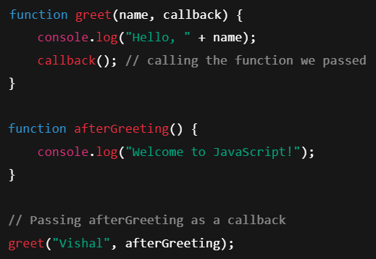

Callback with setTimeout (Async)

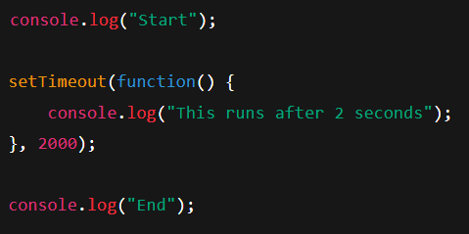

Key Points
- A callback is a function passed as an argument to another function.
- It allows asynchronous execution.
- Used heavily in JavaScript (timers, events, API calls, array methods).

Rule of Thumb
- If the callback is used in a normal function call (like math operations, array methods) → synchronous.
- If the callback is used in timers, events, or I/O tasks → asynchronous.

✅ Synchronous
- Code runs line by line, one after another.
- Each line must finish before the next one starts.
👉 Like standing in a queue at a shop — one person finishes, then the next.

✅ Asynchronous
- Code can start a task and then move on without waiting for it to finish.
- When the task is ready, it comes back with the result.
👉 Like ordering food at a restaurant — you place the order, do other things, and the waiter brings it when it’s ready.

1. Synchronous Callback
- Runs immediately, during the execution of the function.
- Example: Array methods like .map(), .forEach(), .filter()
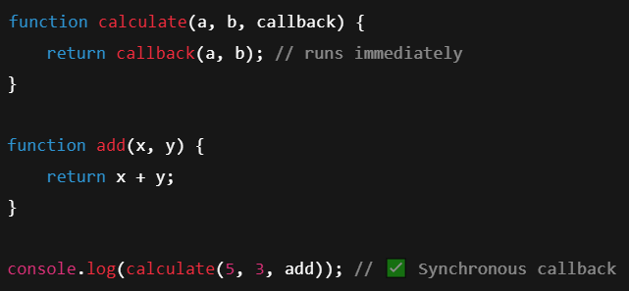

2. Asynchronous Callback
- Runs later, after some time or event.
- Example: setTimeout, API calls, event listeners.

What is Callback Hell?

Callback hell occurs when you have multiple nested callbacks, making the code hard to read, maintain, and debug. This usually happens when performing asynchronous operations (like API calls, file reading, timers) that depend on previous operations.

It’s often called the “Pyramid of Doom” because of the shape of nested callbacks in code.

Problems with Callback Hell
- Difficult to read: Nested indentation grows quickly.
- Hard to maintain: Adding new steps requires even deeper nesting.
- Error handling is tricky: Every callback may need its own error checks.
- Debugging is painful: Stack traces may be confusing.

Call Back Hell Example
